C & D sections

1. Convert the given infix expression, *A + (B – C) * D - (E – F / G) * H* to prefix, by showing in the form of a table, which includes the following:

|  |  |  |  |
| --- | --- | --- | --- |
| Scanned symbol | Action Taken | Stack Contents | Current Prefix |

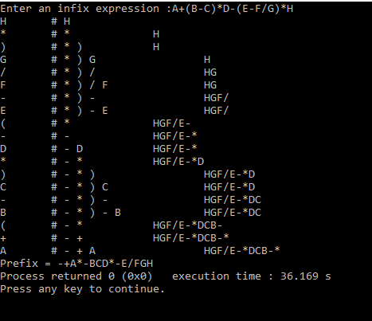

1. Convert the given infix expression, *A + (B – C) * D - (E – F / G) * H*  to postfix, by showing in the form of a table, which includes the following:

|  |  |  |  |
| --- | --- | --- | --- |
| Scanned symbol | Action Taken | Stack Contents | Current Postfix |

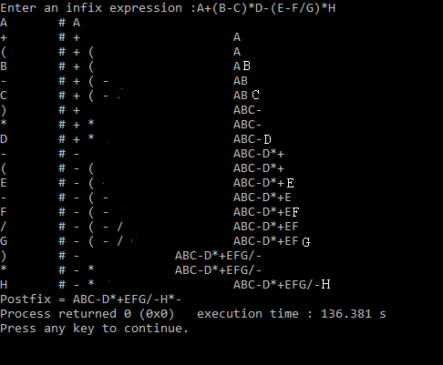

1. Convert the given infix expression, ( *A +B) – C *( D – E) – (F / G) * H* to prefix, by showing in the form of a table, which includes the following:

|  |  |  |  |
| --- | --- | --- | --- |
| Scanned symbol | Action Taken | Stack Contents | Current Prefix |

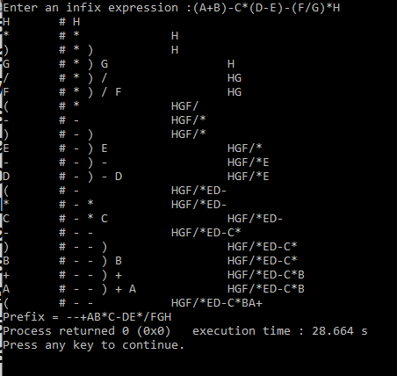

1. Convert the given infix expression, ( *A +B) – C *( D – E) – (F / G) * H* to postfix, by showing in the form of a table, which includes the following:

|  |  |  |  |
| --- | --- | --- | --- |
| Scanned symbol | Action Taken | Stack Contents | Current Postfix |

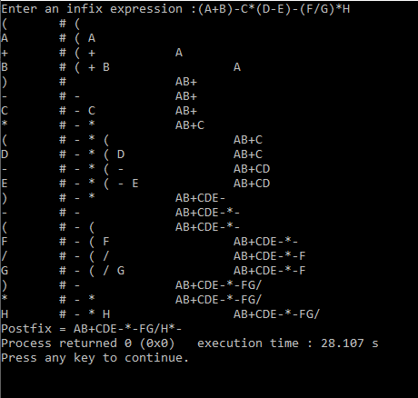

A & B sections

1. Convert the given infix expression, *A / B+ C * D – (E*F+ G) / H* to postfix, by showing in the form of a table, which includes the following:

|  |  |  |  |
| --- | --- | --- | --- |
| Scanned symbol | Action Taken | Stack Contents | Current Postfix |

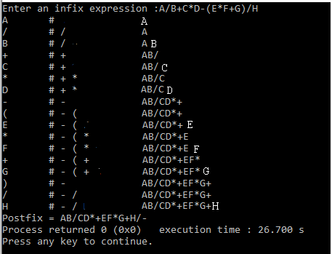

1. Convert the given infix expression, *A / B+ C * D – (E*F+ G) / H* to prefix, by showing in the form of a table, which includes the following:

|  |  |  |  |
| --- | --- | --- | --- |
| Scanned symbol | Action Taken | Stack Contents | Current Postfix |

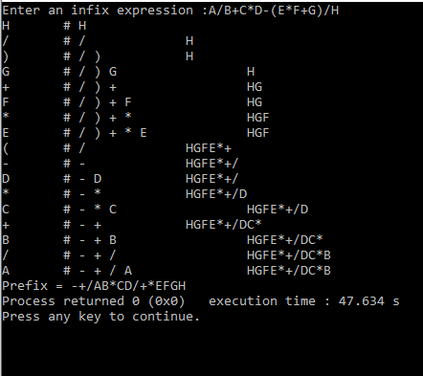

1. Convert the given infix expression, *A – B/(C * D) – E*F+ G / H* to postfix, by showing in the form of a table, which includes the following:

|  |  |  |  |
| --- | --- | --- | --- |
| Scanned symbol | Action Taken | Stack Contents | Current Postfix |

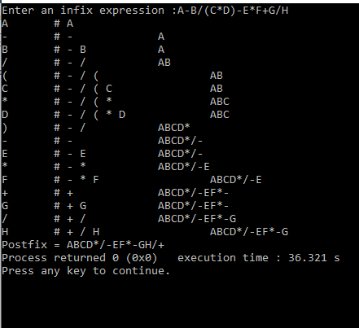

1. Convert the given infix expression, *A – B/ (C * D) –E*F+ G / H* to prefix, by showing in the form of a table, which includes the following:

|  |  |  |  |
| --- | --- | --- | --- |
| Scanned symbol | Action Taken | Stack Contents | Current Postfix |

